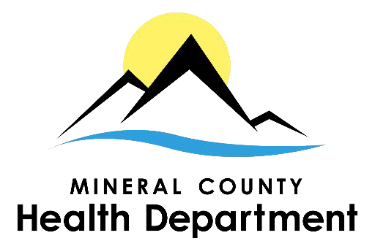

Mineral County Health Department Privacy Statement

Privacy Statement:

This privacy policy discloses the privacy practices for Mineral County Health Department. It will notify you of the following:

- What personally identifiable information is collected from you, how it is used and with whom it may be shared.
- What choices are available to you regarding the use of your data.
- The security procedures in place to protect the misuse of your information.
- How you can correct any inaccuracies in the information.

Information Collection, Use and Sharing:

We are the sole owners of the information collected on this site. We only have access to collect information that you voluntarily give us via email or other direct contact from you. Unless authorized by you, we will only use the information you provide to respond to you regarding the reason you contacted us. The information you provide to us will only be shared with outside entities for the purpose of fulfilling your request or in response to the reason you contacted us. Under no circumstances will we release, sell or rent your information to any other third party public or private entities for the purposes of solicitation.

Your Access to and Control Over Information:
You may opt out of any future contacts from us at any time. You can do the following at any time
by contacting us via phone number given on our website:
  - See what data we have about you, if any;
  - Change/correct any data we have about you;
  - Have us delete any data we have about you; and
  - Express any concern you have about our use of your data.

Security:
We take numerous precautions to protect your information. When you submit sensitive information, your information is protected both online and offline.

For more information see: www.hhs.gov/ocr/privacy/hipaa/understandingconsumers/noticepp.html

1203 E. 5th Ave Superior, MT 59872 | PO Box 488 Superior, MT | Phone: (406) 822-3564 | Fax: (406) 822-3745

